Wolmer’s High School for Girls
Information Technology

Form 4 Teacher: Mrs. McCallum-Rodney

TYPES OF COMPUTER SYSTEMS

The computer market offers a variety of systems to serve computer users’ needs.

Computer systems are usually classified in one of four size categories:
- Small or microcomputers
- Medium-sized or Midrange Computers
- Large or Mainframe Computers
- Super Large or Supercomputers

In general, large computers have greater processing power. For example, big computers can usually process data faster than small computers.

Big computers can also accommodate larger and more powerful peripheral devices

MICROCOMPUTERS

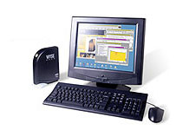

- A microcomputer system is a system driven by a microprocessor chip.
- Microprocessor chip is an entire CPU fitting on a single silicon chip smaller than a dime.
- Microprocessors were quickly integrated into all types of products, leading to powerful handheld calculators, digital watches, electronic toys, and sophisticated controls for household appliances such as microwave ovens and automatic coffee makers.
- Microprocessor makes it possible to build inexpensive computer systems small enough to fit on a desktop or even a shirt pocket.
- Because these computer systems are small enough for one person to use at home or work for personal needs, they are commonly called personal computers (PCs).

- Sizes of computer systems:
  - Desktop Units
  - Portable Units (Laptops and Palmtops)
- Desktop Units are most commonly found in schools, homes, and businesses. Desktops computers come in two models or styles. In the desktop model the system-unit case is designed specifically to rest on a desk. In the tower model the system-unit case stands upright on either a desktop or floor. Tower model cases have more room in which to mount secondary storage units, and they leave more workspace on the desktop.
- Portable Units come in a variety of sizes, including laptop, notebook, sub notebook and palmtop. Laptop Computers were designed primarily for users who needed access to their microcomputers at remote sites. Today, people prefer to carry lighter notebook computers or sub notebook computers. The lighter units also bring smaller physical dimensions, allowing them to fit conveniently into users’ briefcases.

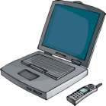

Palmtop Computers look and work a lot like standard pocket calculators. Palmtop devices are sometimes called Personal Digital Assistants (PDAs), and they are specifically geared towards helping users carry out office-oriented tasks such as manipulating numbers, filling in forms, messaging, and other communication functions.

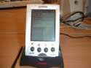

MIDRANGE COMPUTERS
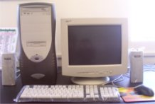

- They are sometimes called minicomputers or minis.
- Most of them fall between microcomputers and mainframes in processing power, although the very smallest midrange computers are virtually indistinguishable from the most powerful microcomputer.
- A small or medium-sized company may simply find a microcomputer system too slow to handle its processing volume. Often, midrange buyers need computer systems that can interact with multiple users at the same time.

MAINFRAMES

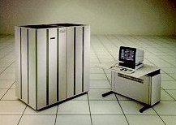
- This is a standard choice for almost any large organization.
- Mainframe computers are large general purpose computers.
- It often operates 24 hours a day, serving thousands of users interacting through display devices during regular business hours or processing large jobs such as payroll and billing late at night.
- Mainframe computers generally require special attention and are kept in a controlled atmosphere. They are multi-tasking and generally used in areas where large databases are maintained e.g. government departments and the airline industry.
- Most mainframes are assigned to handle high-volume processing of business transactions and routine paperwork.

SUPERCOMPUTERS
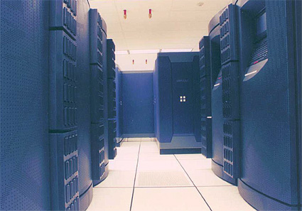

- Large scientific and research laboratories have extraordinary information processing needs. Applications like sending astronauts into space, testing safety and aerodynamic features on cars and aircraft, and weather forecasting require extreme accuracy and extensive computations. To meet such needs, a few vendors offer very large, sophisticated machines called SUPER-COMPUTERS.
- They cost several million dollars each.

Computers And Society
The ability of computers to sort through massive amounts of data and quickly produce useful information for almost any kind of user makes them indispensable tools in modern society. Without computers, businesses could never function at the level they do today. Banks would be overwhelmed by the job of tracking all the transaction they must process. Familiar airline and telephone services would be impossible. Moon exploration and the space shuttle would still belong to science fiction.

But along with these benefits, computers have brought some troubling problems to society ranging from health concerns to personal security and privacy of ethics.

